Batch Copy and Move Videos

Overview
Batch session copy and move can now be done with only a couple clicks with Panopto 5.7.

- Moving or Copying Multiple Recordings
  - Go to your Panopto website and log in with an account that has access to the Folder where the content has been recorded.

  - Once you have found the Folder, click the check boxes to the left of the Sessions that you want to modify (See Figure 1).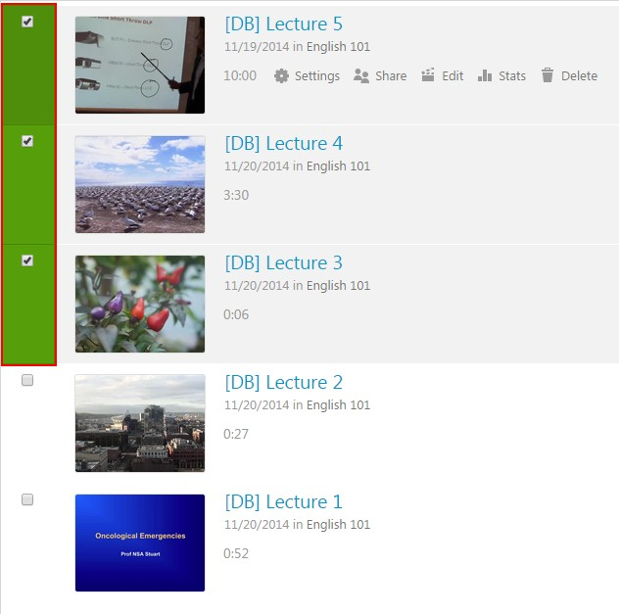
Figure 1
  - Once the file(s) are selected, three options will appear above the sessions to the right of the Filter by date button. These options will be Delete, Copy, and Move, in that order (Fig. 2).

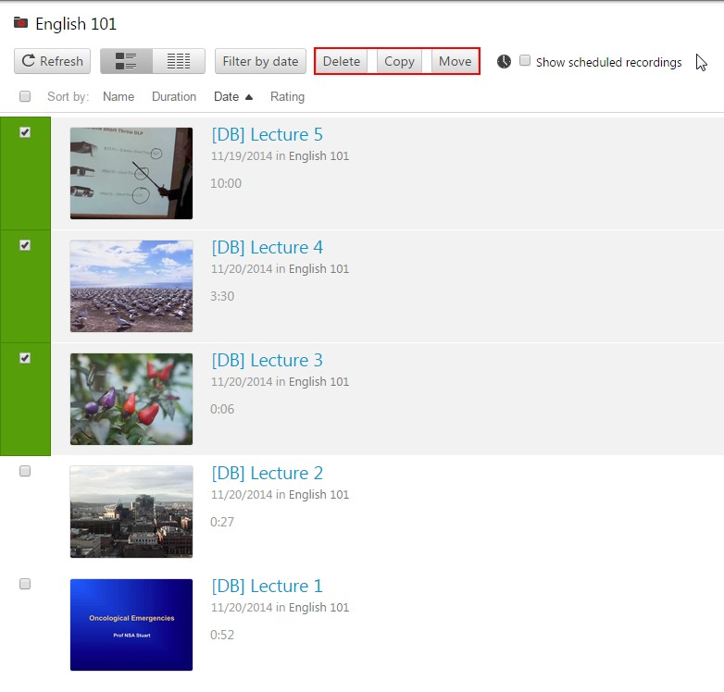
Figure 2

  - From here you can copy the selected sessions to a different folder or move them to a different folder.

  - Select Copy or Move and a window will pop up with a list of the sessions that have been selected (Fig. 3 and 4).

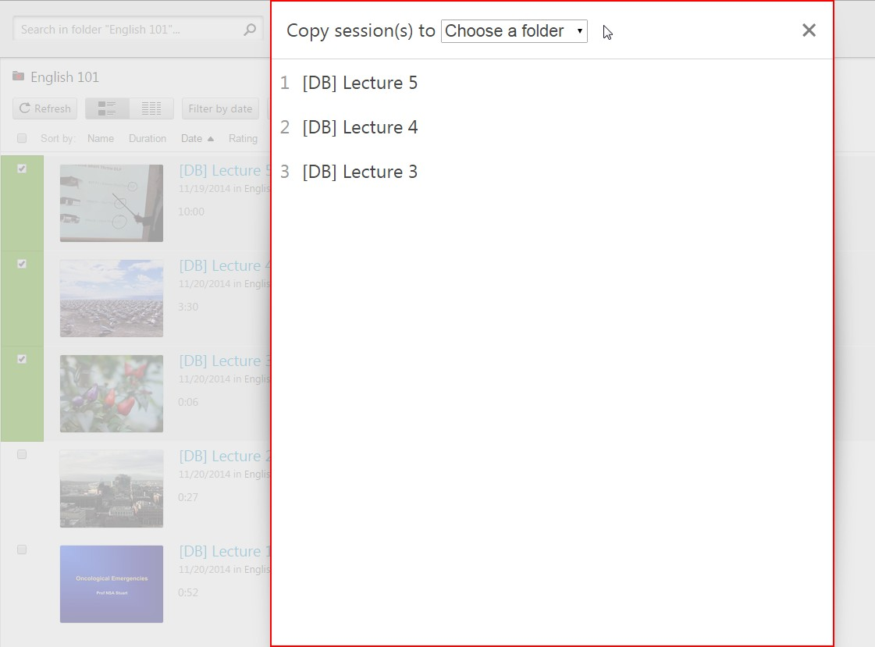
Figure 3

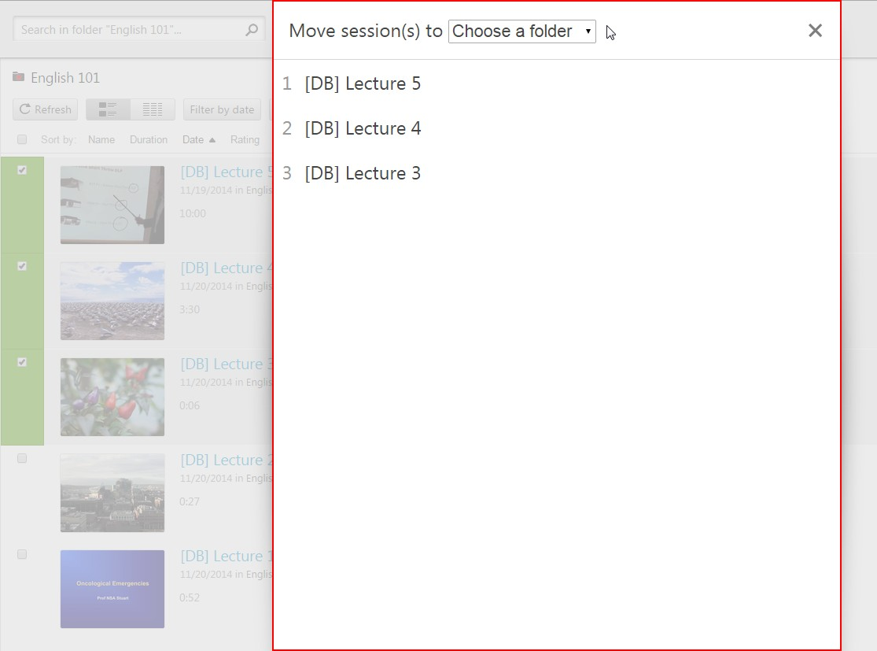
Figure 4
  - Select the folder where you wish to move the sessions from the Choose a folder drop-down menu. This menu will contain all Folders where you have access (Fig. 5).

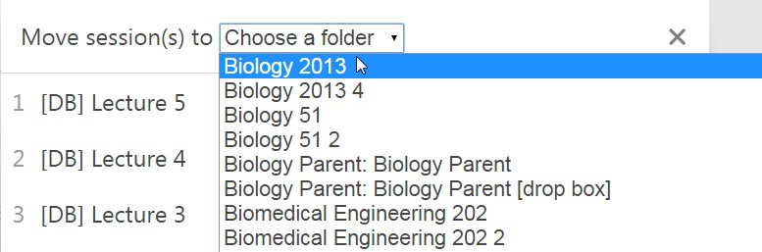
Figure 5

  - Once the folder is selected, a green Copy or Move button will appear to the right of it (Fig. 6).

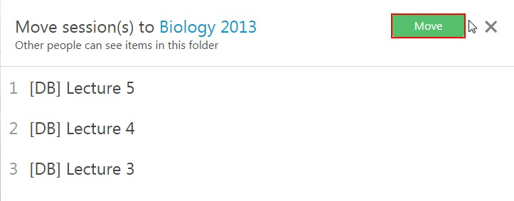
Figure 6

  - Click the button and the sessions will be migrated. Once the word Done appears in place of the green button it is safe to close out the window (Fig. 7).

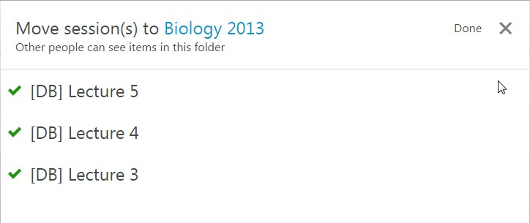
Figure 7

© 2015 Panopto, Inc. All rights reserved.

