Bulk Copy and Move

With Panopto 4.7, bulk session copy and move can now be done with only a couple clicks.

If multiple recordings need to be copied or moved to a different folder, follow these instructions:

Go to your Panopto website (lwtech.hosted.panopto.com) and log in with an account that has access to the Folder that the content has been recorded to.

Once you have found the Folder, click the check boxes to the left of the Sessions that you want to modify.

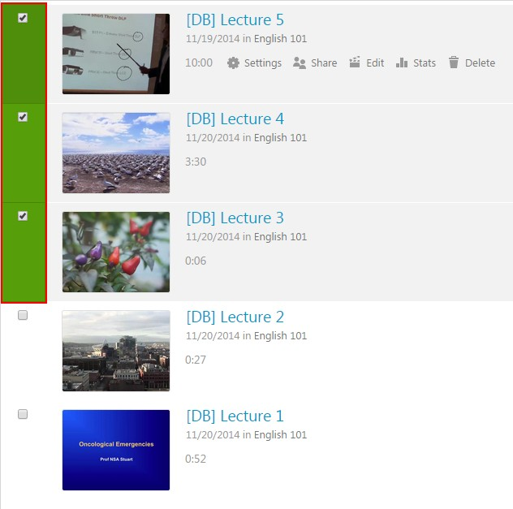

Once file(s) are selected, three options will appear above the sessions, to the right of the 'Filter by date' button. These options will be 'Delete', 'Copy', and 'Move', in that order.

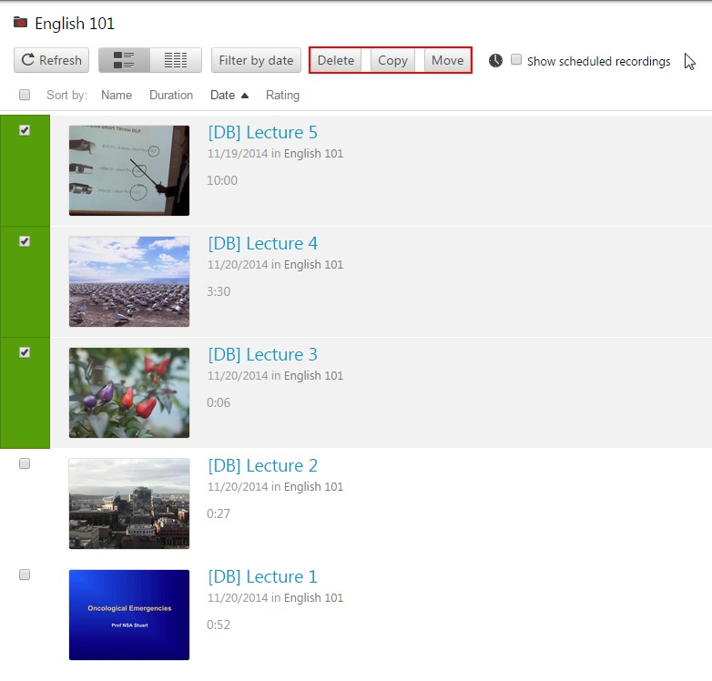

From here you can copy the selected sessions to a different folder or move them to a different folder

Select 'Copy' or 'Move' and a window will pop up with a list of the sessions that have been selected

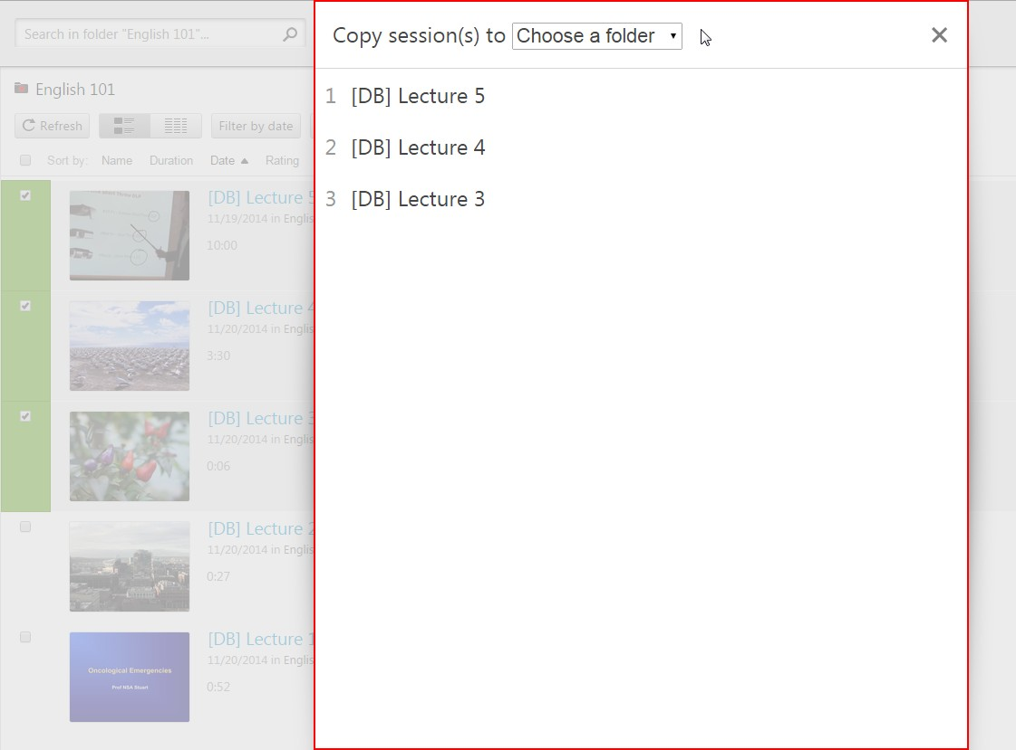

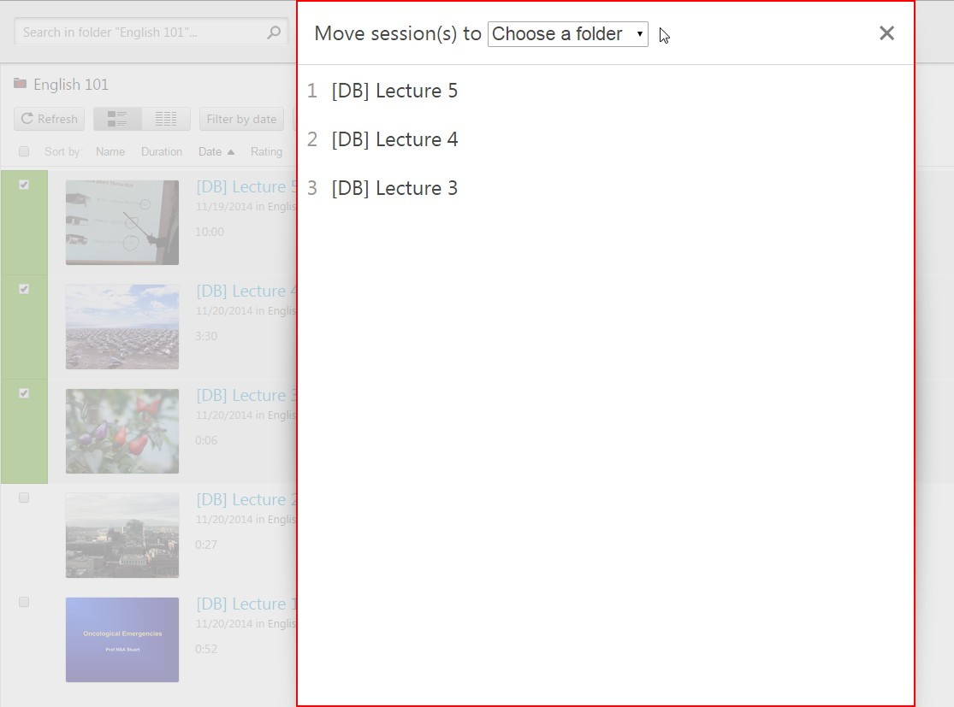

Select the Folder that you wish to move the sessions to from the 'Choose a folder' drop-down menu.

This menu will contain all Folders that you have access to.

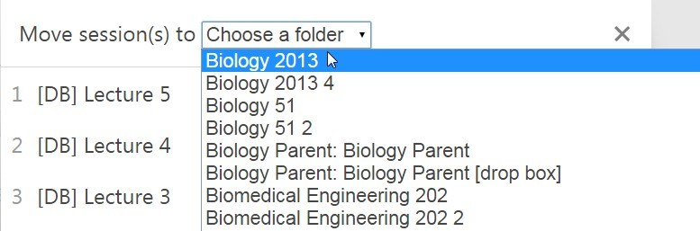

Once the folder is selected, a green 'Copy' or 'Move' button will appear to the right of it.

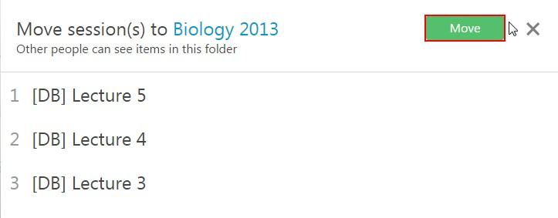

Click the button and the sessions will be migrated. Once the word 'Done' appears in place of the

green button it is safe to close out the window.

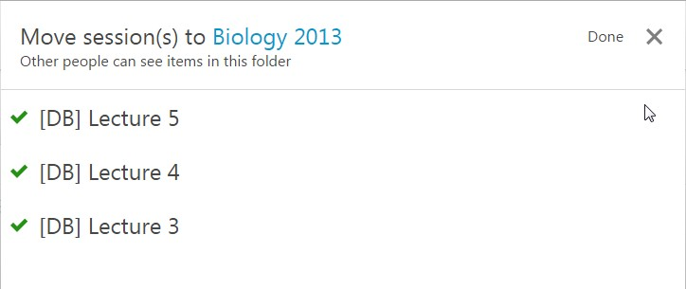

Satisfied?:
Vote up! [1]

Vote down! [2]

Points: 7

Source URL: http://support.panopto.com/documentation/video-management/bulk-copy-and-move

Links:
[1] http://support.panopto.com/vote/node/1123/1/voteUD/thumbs/jyWdXdYBLY8b9g0B9jJAB7-121r1F sWUwjzhpCxRBk8/nojs
[2] http://support.panopto.com/vote/node/1123/-1/voteUD/thumbs/tvWfVPVMI8fK4EE8_AZM3c_-eM8F 0EkaKOzOUoAMmcI/nojs

