Moving a Panopto Video to a New Course

- Open Panopto Recordings in the course where the videos are hosted.
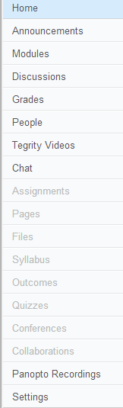

- Hover over the video then click Share.

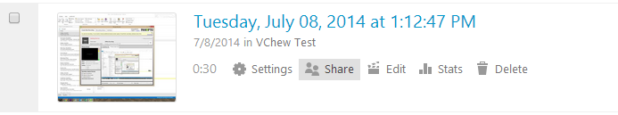

- Click Overview. Click Edit next to the Folder name.
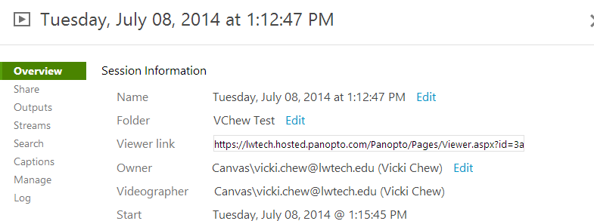

- Use the dropdown arrow to view courses and choose the course you want to move the video to. Click Save. The video will now be in the new course under the Panopto Recordings tab.
