Copying a Panopto Video to a New Course

The process of copying a Panopto video to another course has two parts.
- Copy the Video
- Change the Video Folder

Part One: Copy the Video
- Open Panopto Recordings in the course where the videos are hosted.
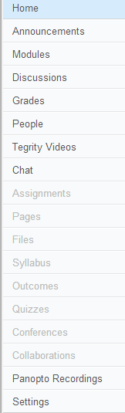

- Hover over the video then click Settings.

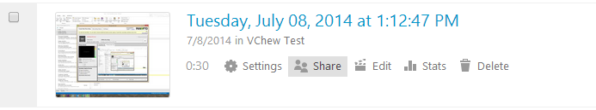

- Click Manage

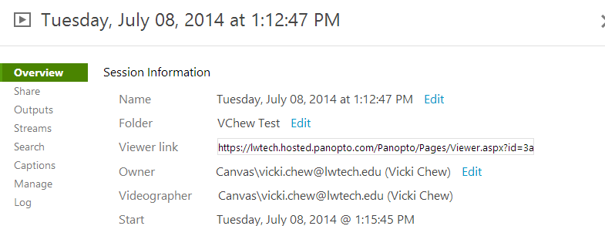

- Under Copy Session, type the Name of the Copied Video. Click Copy.
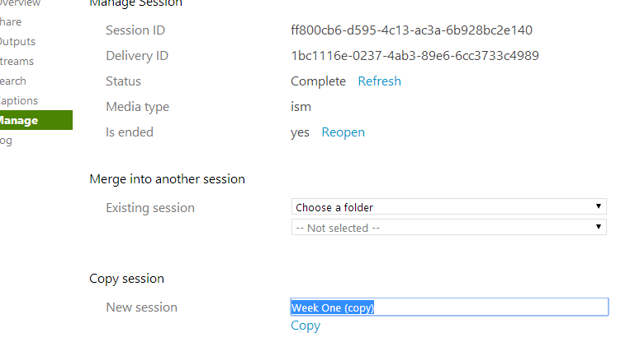

- The system will open a dialog box to confirm the copy. Click OK.

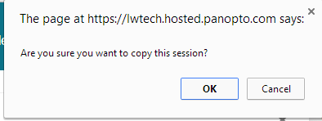

- Status will provide an update on the processing.
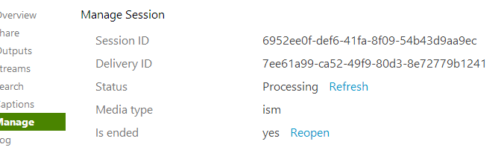
- Once the status is Complete, you will see the Copy in the video listing.
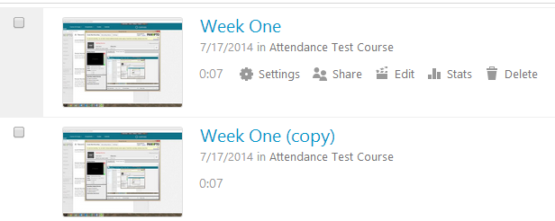

Part Two: Change the Video Folder to the New Class

- Hover over the video then click Settings.
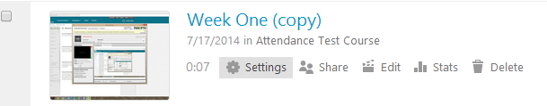

- Click Overview. Click Edit next to the Folder name.

- Use the dropdown arrow to view courses and choose the course you want to move the video to. Click Save.

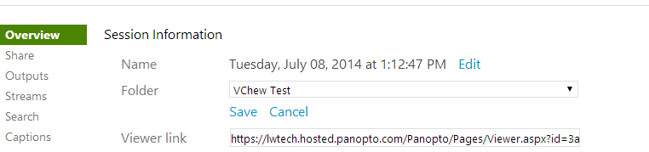

- The video will now be in the new course under the Panopto Recordings tab.

