Panopto: How to Download a Recording

Sometimes instructors may want to download a recording to keep a local copy outside of Panopto or to use in another course outside of the hosting school. Panopto videos are downloaded in MP4 Video format.

- Go into Panopto and locate the video you want to download.
- Click Settings.

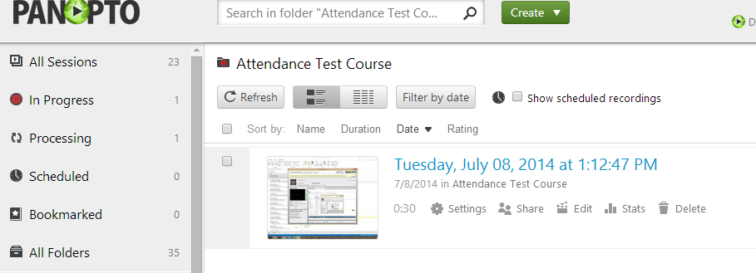

- Click Outputs
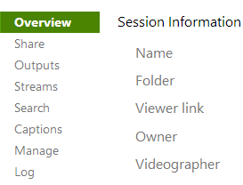

- Choose your desired settings [1] Type and [2] Quality. Click Download Podcast [3].

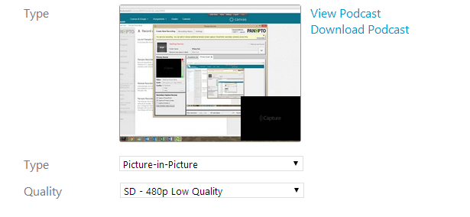
2
1
3

